BASICS Session 4 Exercise Worksheet
Exercise 4.1: Discussing Consequences without Corresponding Feedback
Instructions: Assume you are speaking with a student who expresses a concern about poor sleep and reports drinking heavily 3 times a week (BAC at bedtime = .10, meaning it will take 6.25 hours to metabolize) and they only have 6 hours of sleep opportunity.
Using the information just discussed, write a script in the BASICS Session 4 Exercise Worksheet for how you would discuss this alcohol-related consequence using the Ask-Tell-Ask model.
Ask (for the student’s permission to share the feedback):
Tell (the feedback in your own words):
Ask (for the student’s reaction to the feedback):


Please wait until you are prompted before completing the next exercise.

Exercise 4.2: Discussing Consequences with Corresponding Feedback
Instructions: Using the feedback depicted below (generated for a fictitious student at the University of Missouri), write a script for how you would discuss this alcohol-related consequence using the Ask-Tell-Ask model. You may ask for permission explicitly (e.g., Would it be okay…?) or implicitly (as modeled in the video in relation to financial costs).
Assume the student expressed a goal of maintaining a healthy weight and is not demonstrably experiencing or reporting symptoms that would make you concerned they might have anorexia nervosa (for which discussion of this feedback would be contraindicated).
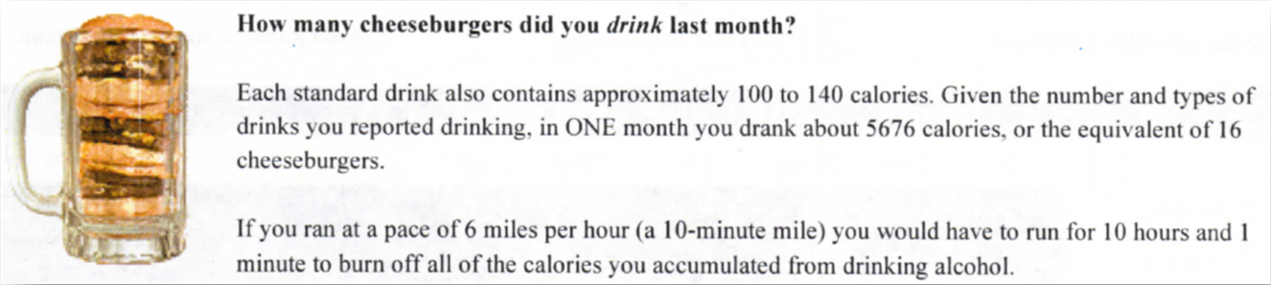

Ask (for the student’s permission to share the feedback):
Tell (the feedback in your own words):
Ask (for the student’s reaction to the feedback):

Please wait until you are prompted before completing the next exercise.

Exercise 4.3: Explaining the Biphasic Effects of Alcohol & the Point of Diminishing Returns
Instructions:
- Remembering what you learned in Session 2 about alcohol myopia, write a script (i.e., the “tell” portion of Ask-Tell-Ask) for how you would explain the biphasic effects of alcohol and the point of diminishing returns to a student who is hoping to avoid “drunk texting my ex.” Try to keep it brief (no more than 6 sentences).

Please wait until you are prompted before completing the next exercise.

Exercise 4.4: Explaining Tolerance
Instructions:
- Write a script (i.e., the “tell” portion of Ask-Tell-Ask) for how you would explain tolerance and the benefits of a “brief vacation” from alcohol to a student who is not yet expressing a commitment to change their drinking behavior yet has concerns about their elevated risk score as depicted in the feedback below (generated for a fictitious student at the University of Missouri). Try to keep it brief (no more than 6 sentences).
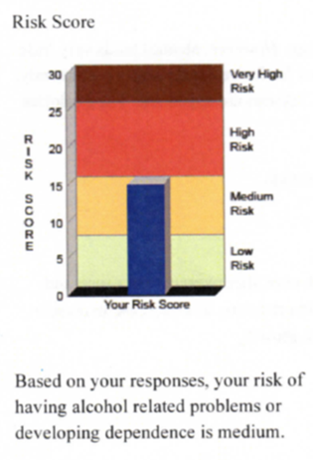
Script:

Please save your responses to this exercise, labeling the file “BASICS Session 4 Exercises - YOUR LAST NAME”.

